TungHo Lin

Txl429

EECS325 PA2 Report

Graphs and tables:

RTT vs Hops : positive relationship

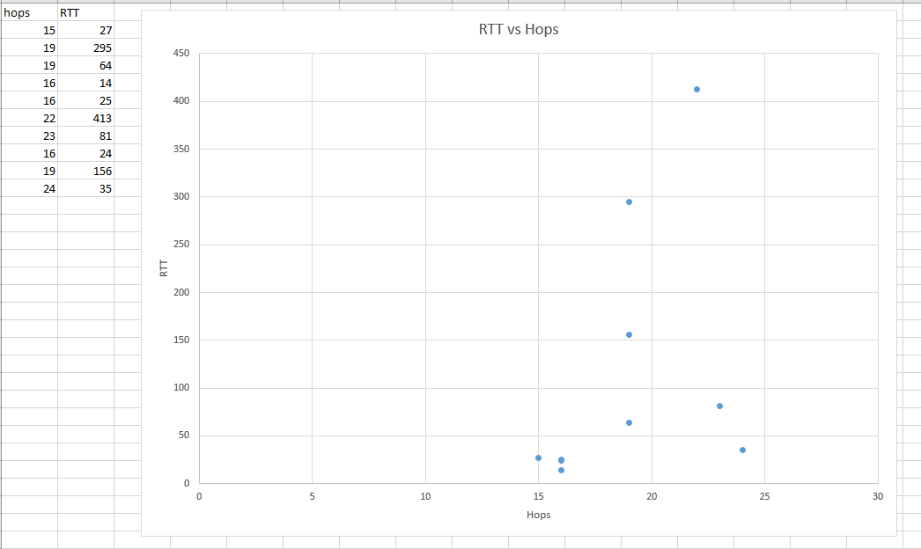

GeoDistance vs Hops: No apparent relationship

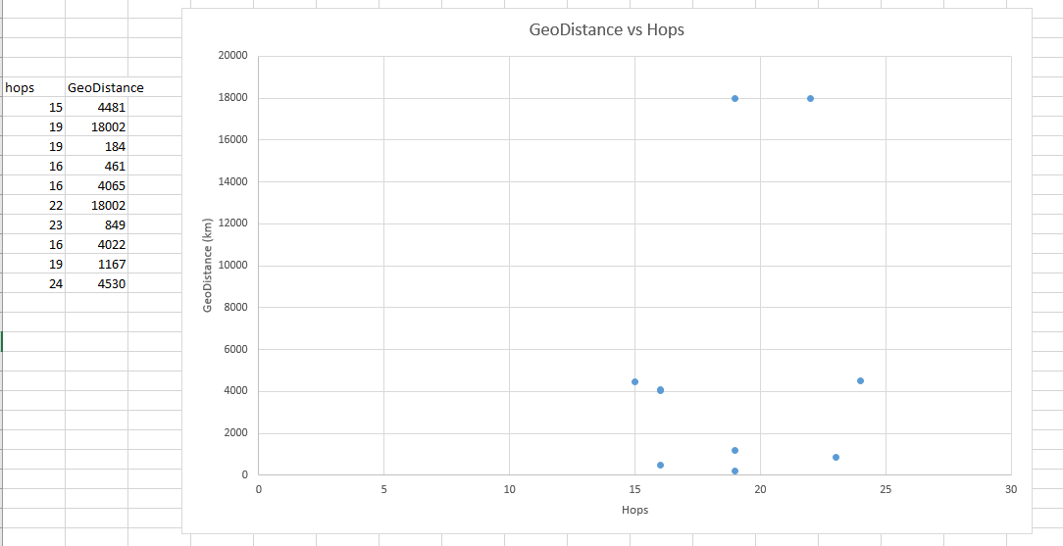

GeoDistance vs RTT: Positive relationship

